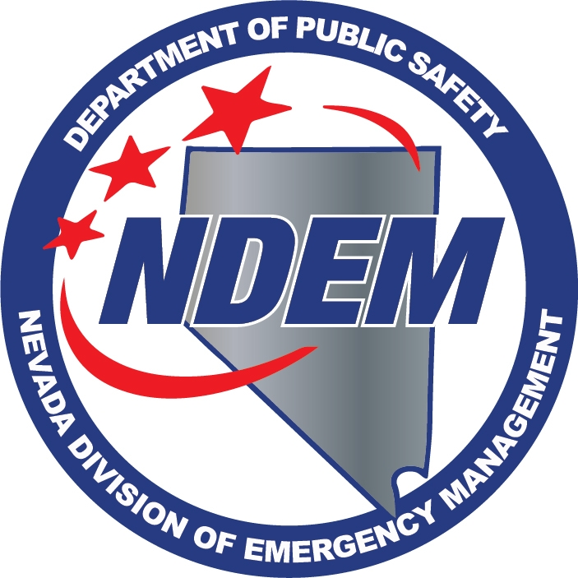 DEPT. OF PUBLIC SAFETY
DIVISION OF EMERGENCY MANAGEMENT
AB 239 REGULATION WORKSHOP
MINUTES

Attendance | Date | October 16, 2015
 | Time | 10:00 AM
 | Location | Grant Sawyer Building  555 E. Washington Ave., Room 4412  Las Vegas, NV 89101
 | Method | Record/Live Stream
 | Recorder | Chris Molnar
 | Present
Caleb Cage | X | Chief/Nevada Division of Emergency Management/Homeland Security Advisor
Samantha Ladich | X | Senior Deputy Attorney General

Call to Order – Caleb Cage
Caleb Cage, Chief of the Nevada Division of Emergency Management, called the workshop to order at 10:00 a.m. He told the attendees the Department of Public Safety, Division of Emergency Management, is responsible for the regulations pursuant to Assembly Bill 239. Chief Cage told the attendees this meeting was a follow up to the meeting held in Carson City on Oct. 14, 2015. He said they had approx. 17 participants to provide input into the workshop.

1. Public Comment

Chief Cage called for public comment, and there was no public comment.

2. Workshop – Overview

Chief Cage told the attendees the Department of Public Safety, Division of Emergency Management, is responsible for the regulations pursuant to Assembly Bill 239. He explained the purpose of the workshop was to solicit comments on regulations related to the operation of Unmanned Aerial Vehicles (UAV) by public agencies, pursuant to AB239. The division seeks input on specific public purposes that are appropriate and necessary for the operation of UAVs by public agencies. He said there could be a broader discussion later, but this is the focus today.

He said the bill contained several uses for UAVs, to include search and rescue, fire services, emergency medical services and protection of critical facilities.

Chief Cage invited the participants to provide input.

Michael Dalley, Captain, Las Vegas Metro Police Department, said the department started looking into UAVs for three main uses. He told the attendees the uses will be developed in three phases. The first phase would be for crime scene documentation, like photography and 4D mapping. He said based on their research, it would cut down on time in the field. He said the second phase would be search and rescue. Currently UAVs require a line of sight, but he pointed out there are drones, for search and rescue purposes, that don’t require line of sight, and would be great when searching in the Red Rock area, as an example, where they could send the UAV out GPS and utilize the camera. He said the third phase, which would be a long way out, is the tactical phase. He explained all of the phases are subject to change. He said they use robots now with cameras and using UAVs would have the same application. It would also require a warrant as they do now. He stated the department has concerns regarding private citizens using UAVs, and they have received a number of calls about citizens using these vehicles to fly over neighbor’s homes, etc. and it has created a problem for law enforcement. He said he was glad see there is language in the bill to address that.

Rich Johnson, Henderson Fire Department, said he is heading up a project using UAVs. He said they are using them to evaluate the effectiveness of using them on structure fires. He said with the current technology of UAVs, through thermo-imaging, they can detect hotspots, which can protect their fire fighters from falling through roofs. He said they are also looking to use them for search and rescue, hazmat reconnaissance, and mass casualty incident reconnaissance. He said that their fire investigators would use them for aerial shots during a fire. He concluded by saying how UAVs would help with the disaster management aspect, for the emergency operation center, by having the capability of sending them out for analysis of the streets to help with the recovery.

Chief Cage asked Mr. Johnson how he would phrase the use of UAVs for hazmat. He responded that hazmat reconnaissance would be the best term. He said they would attach sensor packages to the UAV and essentially do what the guys are hand carrying in now. He said it would be used the same way with mass casualty, only with video image and sensors.

Sal Egilmez, Henderson Fire Department, told the attendees they have been working with a UAV project for about 2 ½ years, before AB 239. He said they were hoping to save approximately $700,000 a year using UAVs, but unfortunately with the new version of AB 239, they won’t be getting that much savings. He said the department is planning on developing a training center at their Eldorado Valley facility for law enforcement throughout the United States. He said because of AB 239, their focus will be accident investigations, as well as using UAVs for crime scene 4D photography. He stated that eventually they would move into search and rescue and are looking at a self-contained unit that could life itself and go out and do roving patrol and return and dock itself to the charging station. He also said he would like the line of sight be relaxed a little. He also would like to see the ability of multiple UAVs be controlled by one user.

Chief Cage said the workshop was very helpful. Some of the ideas mentioned had not been brought up in the Carson City workshop. With no other speakers coming forward, he closed the workshop.

3. Public Comment

Chief Cage called for public comment, and there was no public comment. He adjourned the workshop.

